ELECTRONIC SUPPLEMENTARY MATERIAL

Labour’s pain: strenuous subsistence work, mechanical wear-and-tear, and musculoskeletal pain in a non-industrialized population

Jonathan Stieglitz et al.

METHODS
Study population

Figure S1. Tsimane weave bags for carrying harvested cultigens (A) and hunted game and/or tools (B). Photo credits: Jonathan Stieglitz and Benjamin Trumble.

Participants

Table S1. Descriptive statistics for study variables.
Outcome or predictor | N individuals | Mean or % | SD | Min | Max
Pain outcomes
% with current pain | 388 | 87
Pain durationª (days) | 290^{b,c} | 148.24 | 463.96 | 0 | 3,650
% with chronic pain (≥90 days) | 323^{b} | 35
% with chronic pain (≥180 days) | 315^{b} | 25
Socio-demographics
Age (years) | 388 | 34.10 | 14.00 | 10.90 | 75.10
% male | 388 | 52
Years of schooling | 377 | 1.60 | 2.44 | 0.00 | 13.00
Health indicators: Clinical diagnosis categories
% with any respiratory condition | 373 | 53
% with any musculoskeletal condition | 373 | 42
% with any gastrointestinal condition | 373 | 26
% with any genitourinary condition | 373 | 17
% with any other infection | 373 | 15
% with any circulatory condition | 373 | 6
% with any skin/subcutaneous tissue condition | 373 | 1
Sum of all conditions | 373 | 1.60 | 0.76 | 0.00 | 4.00
Health indicators: Vital signs
Pulse rate (beats/min) | 356 | 74.69 | 8.26 | 60.00 | 98.00
Breathing rate (breaths/min) | 355 | 22.32 | 2.26 | 18.00 | 28.00
Systolic blood pressure (mmHg) | 325 | 105.23 | 15.59 | 80.00 | 180.00
Diastolic blood pressure (mmHg) | 325 | 68.35 | 9.62 | 50.00 | 110.00
Female reproductive history
Age at first birth (years) | 157 | 18.24 | 2.78 | 12.00 | 28.00
Mean interbirth interval (months) | 140 | 32.41 | 14.42 | 12.00 | 114.00
Total number of live births | 186 | 4.89 | 3.96 | 0.00 | 15.00
% giving birth in past year | 186 | 15
ª Refers to the maximum duration reported across all anatomical locations for an individual.
^{b} Sample size is reduced due to missing pain duration data at certain anatomical locations.
^{c} Excludes individuals with any missing pain duration data across all anatomical locations (and includes individuals reporting no pain, i.e. pain duration=0 days).

RESULTS
Self-reports indicate that most pain results from habitual subsistence work.

Figure S2. Self-reported causes of non-chronic (lasting <3 months) and chronic (lasting ≥3 and ≥6 months) pain by sex and age. For non-chronic pain lasting <3 months: n=459 pain attributions for 207 individuals; for chronic pain lasting ≥3 months: n=201 pain attributions for 98 individuals; for chronic pain lasting ≥6 months: n=138 pain attributions for 66 individuals. Note some categories may not be mutually exclusive (e.g. fall and work), and thus the relative contribution of work is a lower-bound estimate. Also note that pain duration data are missing for 69 attributions. Percentages on top of each bar show the prevalence of non-chronic or chronic pain for a given sex and age category. Sample sizes shown on the x-axis refer to pain attributions.

Table S2. Pain duration (days) by attribution, in descending order of frequency (n=660 attributions with complete duration data for 262 individuals). Note some categories may not be mutually exclusive (e.g. fall and work), and thus the duration of pain attributed to work is a lower-bound estimate. Also note that pain duration data are missing for 69 attributions.
Self-reported cause of pain | N | Mean | Median | IQR | Min | Max
Work | 469 | 159.60 | 15.00 | 86.00 | 1.00 | 3650.00
Fall / other accident | 101 | 102.50 | 7.00 | 56.50 | 1.00 | 1460.00
Social | 50 | 121.98 | 7.00 | 356.00 | 2.00 | 720.00
Illness | 15 | 155.47 | 30.00 | 140.00 | 5.00 | 730.00
Weather | 14 | 67.93 | 60.00 | 90.50 | 3.00 | 180.00
Reproduction | 9 | 219.67 | 300.00 | 304.50 | 1.00 | 365.00
Old age | 2 | 1250.00 | 1250.00 | NA | 1040.00 | 1460.00

Figure S3. Work-related pain attributions by sex and age (n=360 attributions for 164 individuals). Note some categories may not be mutually exclusive (e.g. horticulture and overload), and thus the relative contribution of horticulture is a lower-bound estimate. Nonspecific work-related pain attributions precluding further sub-categorization are omitted. “Wood” refers to commercial logging (i.e. wage labor). Sample sizes shown on the x-axis refer to work-related pain attributions.

Table S3. Pain duration (days) by work-related attribution, in descending order of frequency (n=334 attributions for 152 individuals). Note some work sub-categories may not be mutually exclusive (e.g. horticulture and overload), and thus the duration of pain attributed to horticulture is a lower-bound estimate. Also note that pain duration data are missing for 26 attributions.
Work-related pain attribution | N | Mean | Median | IQR | Min | Max
Horticulture | 96 | 95.91 | 14.00 | 63.50 | 1.00 | 790.00
Overload | 85 | 94.22 | 7.00 | 57.00 | 1.00 | 790.00
Transport (e.g. excessive walking) | 60 | 162.08 | 7.00 | 357.00 | 1.00 | 790.00
Hunt or forage | 57 | 185.42 | 30.00 | 353.00 | 2.00 | 1825.00
Wood (i.e. logging as paid laborer) | 19 | 104.21 | 60.00 | 113.00 | 3.00 | 360.00
Fish | 10 | 19.80 | 14.00 | 35.75 | 1.00 | 60.00
Domestic | 7 | 172.00 | 37.00 | 353.00 | 3.00 | 730.00

Pain increases with age, and is more prevalent in the back relative to other anatomical locations.

Table S4. Generalized linear mixed effects model of current pain, including fixed effects of age, sex, and anatomical location, and random effects of individual ID, and community ID (n=2,110 person-observations for 388 individuals across 16 communities).
Variable | Estimate (log odds) | Odds ratio | Std. Error | Pr(>|z|)
Intercept | 1.236 | 3.442 | 0.322 | <0.001
Age (z-score) | 1.027 | 2.792 | 0.113 | <0.001
Male (ref: female) | -0.338 | 0.713 | 0.206 | 0.100
Anatomical location=back | 0.646 | 1.908 | 0.189 | 0.001
Anatomical location=foot | -1.451 | 0.234 | 0.186 | <0.001
Anatomical location=hand | -1.562 | 0.210 | 0.187 | <0.001
Anatomical location=leg | -0.465 | 0.628 | 0.181 | 0.010
Anatomical location=arm (ref) | ----- | ----- | ----- | -----
Random effects | Variance
Individual ID | 2.360
Community ID | 0.825
AIC | 2319.40

Table S5. Generalized linear mixed effects model of pain duration (days), including fixed effects of age, sex, and anatomical location, and random effects of individual ID, and community ID (n=1,946 person-observations for 382 individuals across 16 communities).
Variable | Estimate (log count) | Incident rate ratio | Std. Error | Pr(>|z|)
Intercept | 3.403 | 30.042 | 0.224 | <0.001
Age (z-score) | 0.750 | 2.117 | 0.078 | <0.001
Male (ref: female) | -0.149 | 0.861 | 0.153 | 0.330
Anatomical location=back | 0.302 | 1.352 | 0.086 | <0.001
Anatomical location=foot | -0.431 | 0.650 | 0.111 | <0.001
Anatomical location=hand | -0.386 | 0.680 | 0.103 | <0.001
Anatomical location=leg | -0.022 | 0.979 | 0.096 | 0.820
Anatomical location=arm (ref) | ----- | ----- | ----- | -----
Zero-inflation model | Estimate (log odds) | Odds ratio | Std. Error | Pr(>|z|)
Intercept | -1.823 | 0.162 | 0.130 | <0.001
Random effects | Variance
Individual ID | 1.495
Community ID | 0.370
AIC | 12147.9

Figure S4. Pain duration (days) by age, sex, and anatomical location (n=1,946 person-observations for 382 individuals across 16 villages). Pain duration is estimated from the model in Table S5.

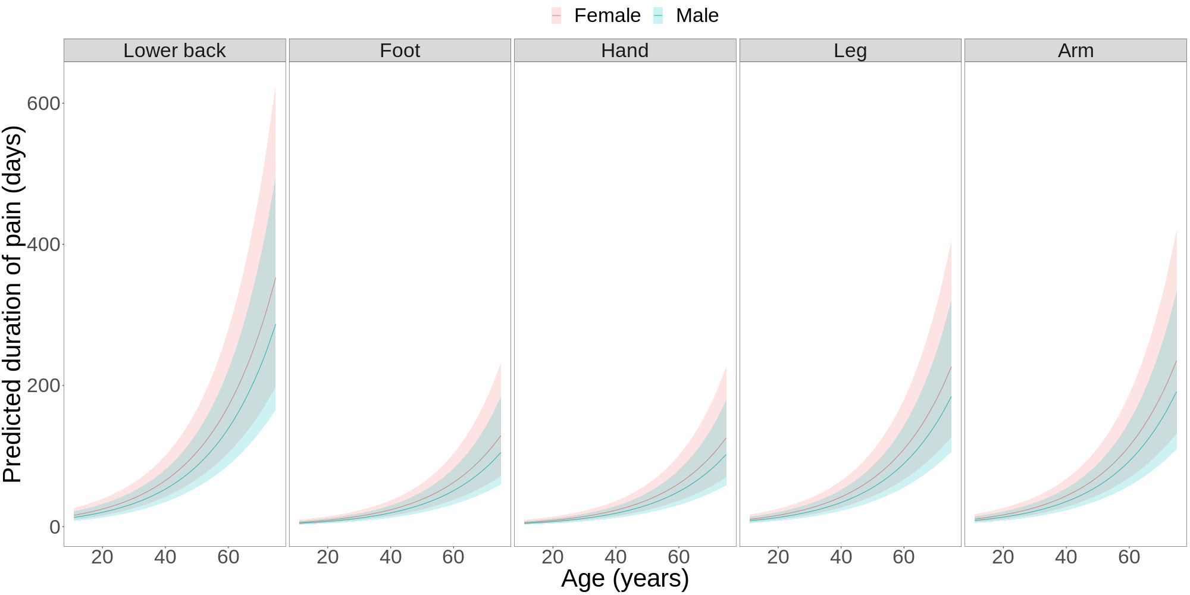

Table S6. Generalized linear mixed effects model of chronic pain (lasting ≥3 months), including fixed effects of age, sex, and anatomical location, and random effects of individual ID, and community ID (n=1,946 person-observations for 382 individuals across 16 communities).
Variable | Estimate (log odds) | Odds ratio | Std. Error | Pr(>|z|)
Intercept | -3.955 | 0.019 | 0.728 | <0.001
Age (z-score) | 1.273 | 3.570 | 0.200 | <0.001
Male (ref: female) | -0.532 | 0.587 | 0.364 | 0.144
Anatomical location=back | 0.861 | 2.366 | 0.277 | 0.002
Anatomical location=foot | -0.642 | 0.526 | 0.305 | 0.035
Anatomical location=hand | -0.492 | 0.611 | 0.297 | 0.097
Anatomical location=leg | -0.313 | 0.732 | 0.296 | 0.290
Anatomical location=arm (ref) | ----- | ----- | ----- | -----
Random effects | Variance
Individual ID | 5.134
Community ID | 4.363
AIC | 1131.3

Table S7. Generalized linear mixed effects model of chronic pain (lasting ≥6 months), including fixed effects of age, sex, and anatomical location, and random effects of individual ID, and community ID (n=1,946 person-observations for 382 individuals across 16 communities).
Variable | Estimate (log odds) | Odds ratio | Std. Error | Pr(>|z|)
Intercept | -8.000 | <0.001 | 0.832 | <0.001
Age (z-score) | 0.949 | 2.583 | 0.358 | 0.008
Male (ref: female) | -0.498 | 0.608 | 0.673 | 0.459
Anatomical location=back | 1.313 | 3.718 | 0.391 | 0.001
Anatomical location=foot | 0.004 | 1.004 | 0.402 | 0.991
Anatomical location=hand | -0.673 | 0.510 | 0.424 | 0.112
Anatomical location=leg | 0.289 | 1.335 | 0.398 | 0.468
Anatomical location=arm (ref) | ----- | ----- | ----- | -----
Random effects | Variance
Individual ID | 50.59
Community ID | <0.001
AIC | 820.6

Figure S5. Predicted probability of chronic pain (lasting ≥3 months) by age, sex, and anatomical location (n=1,946 person-observations for 382 individuals across 16 villages). Probabilities are estimated from the model in Table S6.

Pain increases with disease burden, particularly for musculoskeletal conditions.

Table S8. Generalized linear mixed effects model of current pain, including fixed effects of age, sex, anatomical location, and summed clinical diagnoses, and random effects of individual ID, and community ID (n=2,035 person-observations for 373 individuals across 16 communities).
Variable | Estimate (log odds) | Odds ratio | Std. Error | Pr(>|z|)
Intercept | 1.259 | 3.523 | 0.306 | <0.001
Age (z-score) | 0.935 | 2.548 | 0.115 | <0.001
Male (ref: female) | -0.407 | 0.666 | 0.206 | 0.048
Anatomical location=back | 0.648 | 1.912 | 0.192 | 0.001
Anatomical location=foot | -1.461 | 0.232 | 0.189 | <0.001
Anatomical location=hand | -1.559 | 0.210 | 0.189 | <0.001
Anatomical location=leg | -0.464 | 0.629 | 0.183 | 0.011
Anatomical location=arm (ref) | ----- | ----- | ----- | -----
Summed diagnoses (z-score) | 0.341 | 1.407 | 0.107 | 0.001
Random effects | Variance
Individual ID | 2.202
Community ID | 0.680
AIC | 2234.3

Table S9. Generalized linear mixed effects model of pain duration (days), including fixed effects of age, sex, anatomical location, and summed clinical diagnoses, and random effects of individual ID, and community ID (n=1,876 person-observations for 367 individuals across 16 communities). Inclusion of a zero-inflation parameter results in a model convergence problem, and thus this parameter is omitted.
Variable | Estimate (log count) | Incident rate ratio | Std. Error | Pr(>|z|)
Intercept | 3.547 | 34.697 | 0.219 | <0.001
Age (z-score) | 0.624 | 1.866 | 0.072 | <0.001
Male (ref: female) | -0.254 | 0.775 | 0.140 | 0.069
Anatomical location=back | 0.401 | 1.494 | 0.084 | <0.001
Anatomical location=foot | -0.617 | 0.540 | 0.105 | <0.001
Anatomical location=hand | -0.633 | 0.531 | 0.102 | <0.001
Anatomical location=leg | -0.042 | 0.959 | 0.091 | 0.649
Anatomical location=arm (ref) | ----- | ----- | ----- | -----
Summed diagnoses (z-score) | 0.195 | 1.215 | 0.071 | 0.006
Random effects | Variance
Individual ID | 1.195
Community ID | 0.335
AIC | 11836.8

Table S10. Generalized linear mixed effects model of chronic pain (lasting ≥3 months), including fixed effects of age, sex, anatomical location, and summed clinical diagnoses, and random effects of individual ID, and community ID (n=1,876 person-observations for 367 individuals across 16 communities).
Variable | Estimate (log odds) | Odds ratio | Std. Error | Pr(>|z|)
Intercept | -3.795 | 0.022 | 0.703 | <0.001
Age (z-score) | 1.133 | 3.105 | 0.195 | <0.001
Male (ref: female) | -0.697 | 0.498 | 0.358 | 0.051
Anatomical location=back | 0.811 | 2.249 | 0.280 | 0.004
Anatomical location=foot | -0.645 | 0.525 | 0.306 | 0.035
Anatomical location=hand | -0.493 | 0.611 | 0.298 | 0.098
Anatomical location=leg | -0.321 | 0.726 | 0.297 | 0.280
Anatomical location=arm (ref) | ----- | ----- | ----- | -----
Summed diagnoses (z-score) | 0.621 | 1.861 | 0.182 | 0.001
Random effects | Variance
Individual ID | 4.541
Community ID | 4.064
AIC | 1093.7

Table S11. Generalized linear mixed effects model of chronic pain (lasting ≥6 months), including fixed effects of age, sex, anatomical location, and summed clinical diagnoses, and random effects of individual ID, and community ID (n=1,876 person-observations for 367 individuals across 16 communities).
Variable | Estimate (log odds) | Odds ratio | Std. Error | Pr(>|z|)
Intercept | -5.725 | 0.003 | 0.883 | <0.001
Age (z-score) | 1.380 | 3.973 | 0.288 | <0.001
Male (ref: female) | -0.893 | 0.409 | 0.502 | 0.075
Anatomical location=back | 1.073 | 2.925 | 0.353 | 0.002
Anatomical location=foot | -0.086 | 0.917 | 0.369 | 0.815
Anatomical location=hand | -0.586 | 0.557 | 0.384 | 0.128
Anatomical location=leg | 0.152 | 1.164 | 0.364 | 0.677
Anatomical location=arm (ref) | ----- | ----- | ----- | -----
Summed diagnoses (z-score) | 0.489 | 1.631 | 0.256 | 0.056
Random effects | Variance
Individual ID | 8.802
Community ID | 3.248
AIC | 824.0

Figure S6. Associations between pain outcomes and clinical diagnoses. Point estimates (95% CIs) are from generalized linear mixed models including fixed effects of age, sex, and anatomical location, and random effects of individual ID and community ID. Each model includes a binary term indicating presence or absence of each of the seven broad illness categories (e.g. respiratory, musculoskeletal, etc.), or the sum across all seven illness categories. Clinical parameters are modeled individually and separately.

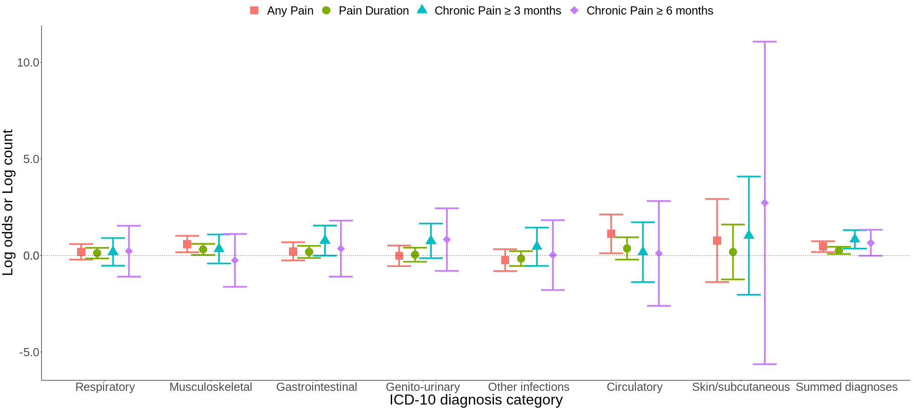

Table S12. Summary of model fit indices for pain outcomes as a function of clinical diagnoses. Shown below are AIC values (logLik). The first model shown is the baseline model including fixed effects of age, sex, and anatomical location, and random effects of individual ID and community ID (i.e. no clinical parameters are included). Subsequent models include a binary term indicating presence or absence of each of the seven broad illness categories (e.g. respiratory, musculoskeletal, etc.), or the sum across all seven illness categories. Clinical parameters are initially modeled individually and separately; parameters showing associations (p≤0.10) with a given pain outcome are then simultaneously included in later models shown in the final two rows of the table. Sample sizes are identical across models for a given pain outcome (i.e. rows with missing clinical diagnosis data [which comprise 4% of all person-observations and individuals] are omitted).
Model | Does illness category parameter predict pain outcome? Numbers in the column below (range: 1-3) refer to pain outcome (labeled in columns to the right) associated with illness category parameters shown in rows in the column to the left. Asterisks in the column below indicate significance level; blank indicates no association (p>0.10) between the illness category parameter and pain outcome. All significant associations are in the predicted positive direction. | Pain outcomes  AIC values  (log likelihood)
 |  | 1—Current pain | 2--Pain duration | 3--Chronic pain
 |  |  |  | 3a)  ≥3 months | 3b)  ≥6 months
Baseline:  Pain outcome ~ age + male + anatomical location + (1 | pid) + (1 | comID) | ----- | 2319.4  (-1150.7) | 12147.9  (-6062.9) | 1131.3  (-556.6) | 820.6  (-401.3)
Baseline + respiratory |  | 2243.8  (-1111.9) | 11843.6  (-5910.8) | 1105.7  (-542.9) | 808.2  (-394.1)
Baseline + musculoskeletal | 1**; 2* | 2237.2  (-1108.6) | 11839.8  (-5908.9) | 1105.2  (-542.6) | 808.2  (-394.1)
Baseline + gastrointestinal | 3a* | 2243.8  (-1111.9) | 11843.0  (-5910.5) | 1102.2  (-541.1) | 808.1  (-394.1)
Baseline + genitourinary | 3a^ | 2244.6  (-1112.3) | 11844.3  (-5911.1) | 1103.2  (-541.6) | 807.4  (-393.7)
Baseline + other infection |  | 2243.9  (-1112.0) | 11843.6  (-5910.8) | 1105.2  (-542.6) | 808.3  (-394.2)
Baseline + circulatory | 1* | 2239.7  (-1109.9) | 11842.8  (-5910.4) | 1105.9  (-543.0) | 808.3  (-394.2)
Baseline + skin/subcutaneous |  | 2244.1  (-1112.1) | 11844.3  (-5911.1) | 1105.5  (-542.8) | 807.8  (-393.9)
Baseline + summed diagnoses | 1***; 2**; 3a***; 3b^ | 2234.3  (-1107.1) | 11836.8  (-5907.4) | 1093.7  (-536.8) | 824.0  (-402.0)
Baseline + summed diagnoses + musculoskeletal + circulatory | summed diagnoses1*; 2^ + musculoskeletal1* + circulatory1^ | 2232.1  (-1104.0) | 11838.6  (-5906.3) | ----- | -----
Baseline + summed diagnoses + gastrointestinal + genitourinary | summed diagnoses3a** | ----- | ----- | 1096.4  (-536.2) | -----
^p≤0.10 *p≤0.05 **p≤0.01 ***p≤0.001

For women, pain is not associated with reproductive history.

Figure S7. Associations between indicators of female reproductive history and pain outcomes. Point estimates (95% CIs) are from generalized linear mixed models including fixed effects of age, anatomical location, and the sum of clinical diagnosis categories, and random effects of individual ID and community ID. Each indicator of reproductive effort is modeled individually and separately. Continuous predictors are z-scored.

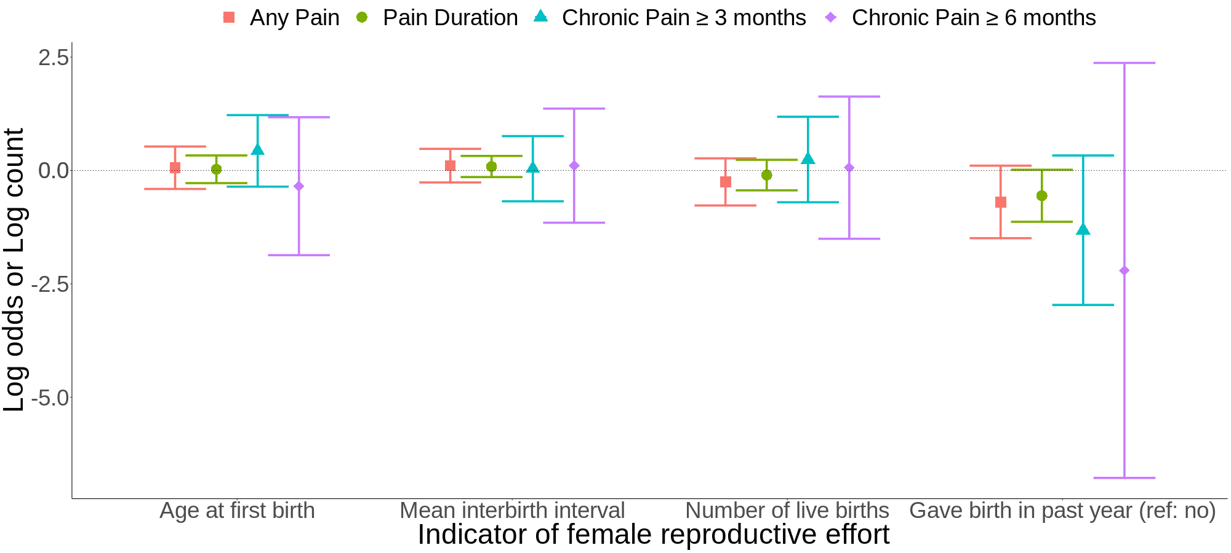

Table S13. Summary of model fit indices for women’s pain outcomes as a function of women’s reproductive history. Shown below are AIC values (logLik). The first model shown is the baseline model including fixed effects of age, anatomical location, and the sum of clinical diagnosis categories, and random effects of individual ID and community ID (i.e. no reproductive history parameters are included). Subsequent models include indicators of female reproductive history, which are modeled individually and separately. Sample sizes are identical across models for a given pain outcome.
Model | Does reproductive history parameter predict pain outcome? Numbers in the column below (range: 1-3) refer to pain outcome (labeled in columns to the right) associated with female reproductive history parameters shown in rows in the column to the left. Asterisks in the column below indicate significance level; blank indicates no association (p>0.10) between the reproductive history parameter and pain outcome. | Pain outcomes
 |  | 1—Current pain | 2--Pain duration | 3--Chronic pain
 |  |  |  | 3a:  ≥3 months | 3b:  ≥6 months
Baseline:  Pain outcome ~ age + anatomical location + sum of illness categories + (1 | pid) + (1 | comID) | ----- | 767.3  (-374.7) | 4621.9  (-2300.9) | 441.8  (-211.9) | 334.4  (-158.2)
Baseline + age at first birth |  | 769.0  (-374.5) | 4623.8  (-2300.9) | 442.4  (-211.2) | 336.0  (-158.0)
Baseline + mean interbirth interval |  | 769.1  (-374.5) | 4623.4  (-2300.7) | 443.7  (-211.9) | 336.3  (-158.1)
Baseline + number of live births |  | 768.8  (-374.4) | 4623.6  (-2300.8) | 443.7  (-211.8) | 336.4  (-158.2)
Baseline + gave birth in past year (reference: no) | 2^ (note the parameter estimate is negative not positive) | 766.8  (-373.4) | 4620.6  (-2299.3) | 442.3  (-211.2) | 335.3  (-157.7)
^p≤0.10 *p≤0.05 **p≤0.01 ***p≤0.001

Pain declines with schooling, but most participants lack schooling.

Table S14. Generalized linear mixed effects model of current pain, including fixed effects of age, sex, anatomical location, summed clinical diagnoses, and years of schooling, and random effects of individual ID, and community ID (n=2,001 person-observations for 366 individuals across 16 communities).
Variable | Estimate (log odds) | Odds ratio | Std. Error | Pr(>|z|)
Intercept | 1.077 | 2.936 | 0.312 | 0.001
Age (z-score) | 0.814 | 2.256 | 0.117 | <0.001
Male (ref: female) | -0.187 | 0.830 | 0.211 | 0.376
Anatomical location=back | 0.694 | 2.001 | 0.195 | <0.001
Anatomical location=foot | -1.428 | 0.240 | 0.190 | <0.001
Anatomical location=hand | -1.511 | 0.221 | 0.191 | <0.001
Anatomical location=leg | -0.426 | 0.653 | 0.185 | 0.021
Anatomical location=arm (ref) | ----- | ----- | ----- | -----
Summed diagnoses (z-score) | 0.339 | 1.404 | 0.106 | 0.001
Years of schooling (z-score) | -0.454 | 0.635 | 0.122 | <0.001
Random effects | Variance
Individual ID | 2.077
Community ID | 0.758
AIC | 2180.7

Table S15. Generalized linear mixed effects model of pain duration (days), including fixed effects of age, sex, anatomical location, summed clinical diagnoses, and years of schooling, and random effects of individual ID, and community ID (n=1,847 person-observations for 360 individuals across 16 communities).
Variable | Estimate (log count) | Incident rate ratio | Std. Error | Pr(>|z|)
Intercept | 3.367 | 29.004 | 0.224 | <0.001
Age (z-score) | 0.621 | 1.861 | 0.080 | <0.001
Male (ref: female) | -0.122 | 0.885 | 0.157 | 0.436
Anatomical location=back | 0.298 | 1.347 | 0.090 | 0.001
Anatomical location=foot | -0.402 | 0.669 | 0.117 | 0.001
Anatomical location=hand | -0.343 | 0.710 | 0.110 | 0.002
Anatomical location=leg | -0.001 | 0.999 | 0.100 | 0.994
Anatomical location=arm (ref) | ----- | ----- | ----- | -----
Summed diagnoses (z-score) | 0.243 | 1.274 | 0.077 | 0.002
Years of schooling (z-score) | -0.265 | 0.767 | 0.100 | 0.008
Zero-inflation model | Estimate (log odds) | Odds ratio | Std. Error | Pr(>|z|)
Intercept | -1.777 | 0.169 | 0.107 | <0.001
Random effects | Variance
Individual ID | 1.454
Community ID | 0.373
AIC | 11659.7

Table S16. Generalized linear mixed effects model of chronic pain (lasting ≥3 months), including fixed effects of age, sex, anatomical location, summed clinical diagnoses, and years of schooling, and random effects of individual ID, and community ID (n=1,847 person-observations for 360 individuals across 16 communities).
Variable | Estimate (log odds) | Odds ratio | Std. Error | Pr(>|z|)
Intercept | -3.753 | 0.023 | 0.719 | <0.001
Age (z-score) | 1.135 | 3.110 | 0.208 | <0.001
Male (ref: female) | -0.700 | 0.497 | 0.376 | 0.063
Anatomical location=back | 0.804 | 2.234 | 0.280 | 0.004
Anatomical location=foot | -0.647 | 0.523 | 0.306 | 0.035
Anatomical location=hand | -0.476 | 0.621 | 0.298 | 0.110
Anatomical location=leg | -0.320 | 0.726 | 0.297 | 0.281
Anatomical location=arm (ref) | ----- | ----- | ----- | -----
Summed diagnoses (z-score) | 0.615 | 1.850 | 0.183 | 0.001
Years of schooling (z-score) | 0.072 | 1.075 | 0.210 | 0.732
Random effects | Variance
Individual ID | 4.502
Community ID | 4.319
AIC | 1089.8

Table S17. Generalized linear mixed effects model of chronic pain (lasting ≥6 months), including fixed effects of age, sex, anatomical location, summed clinical diagnoses, and years of schooling, and random effects of individual ID, and community ID (n=1,847 person-observations for 360 individuals across 16 communities).
Variable | Estimate (log odds) | Odds ratio | Std. Error | Pr(>|z|)
Intercept | -7.593 | 0.001 | 0.886 | <0.001
Age (z-score) | 1.045 | 2.845 | 0.405 | 0.010
Male (ref: female) | -0.827 | 0.437 | 0.720 | 0.251
Anatomical location=back | 1.287 | 3.622 | 0.393 | 0.001
Anatomical location=foot | -0.081 | 0.922 | 0.404 | 0.841
Anatomical location=hand | -0.650 | 0.522 | 0.423 | 0.125
Anatomical location=leg | 0.206 | 1.229 | 0.400 | 0.606
Anatomical location=arm (ref) | ----- | ----- | ----- | -----
Summed diagnoses (z-score) | 0.323 | 1.381 | 0.336 | 0.336
Years of schooling (z-score) | 0.351 | 1.421 | 0.331 | 0.289
Random effects | Variance
Individual ID | 45.59
Community ID | <0.001
AIC | 802.9

Figure S8. Work-related pain attributions by years of schooling (n=352 attributions for 161 individuals [pooled across sexes]). Note some categories may not be mutually exclusive (e.g. horticulture and overload), and thus the relative contribution of horticulture is a lower-bound estimate. Nonspecific work-related pain attributions precluding further sub-categorization are omitted. “Wood” refers to commercial logging (i.e. wage labor).

Figure S9. Accident-related pain attributions by years of schooling (n=50 attributions for 32 individuals [pooled across sexes]). Nonspecific accident-related pain attributions precluding further sub-categorization are omitted. Years of schooling bins are broader relative to those in Figure S8 due to the reduced sample size.

